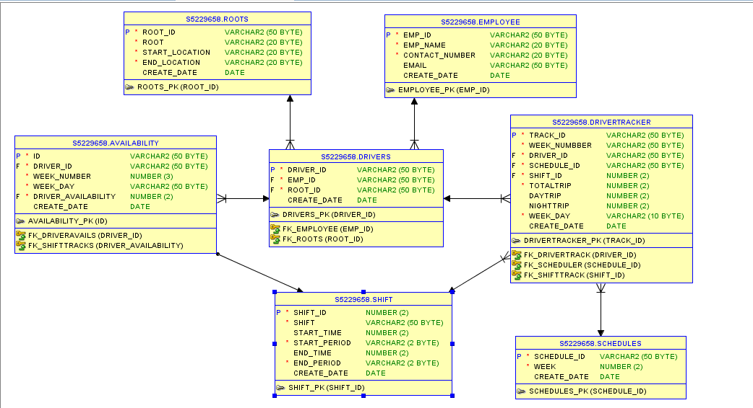

Roots - these consist of a start and end location (text) and a unique identifier.

Employee – these consist off all employee working in given organization regardless of their role.

Drivers - we need to track a driver name and their employee number and the route that they are assigned to, drivers only ever drive the same route (Emp_ID unique).

Availability – store all availability for each driver.

1 means driver is available for first shift only on that day.

2 means driver is available for second shift only on that that day.

12 means available for any shift for that day.

Shift - there is a first(morning) and second (afternoon) shift the morning shift starts at 6:00 AM and finishes at 12:00 PM. The afternoon shift starts at 12:00 PM and finishes at 6:00 PM.

Schedule – we need to track schedule for each week.

Driver Tracker – store all information of driver and their plan for current week.

There are four option in application.

1. Add Roots : If user wants to add new route.
2. Add Employee: To add new employee.
3. Show Roots: To display all roots and later use can assign driver on that route.
4. Show current week timetable: To display current week schedule.
5. Add roots.

If you have selected 1 then first it will as you how many roots you want to add? According to your response it will allow you to add route.

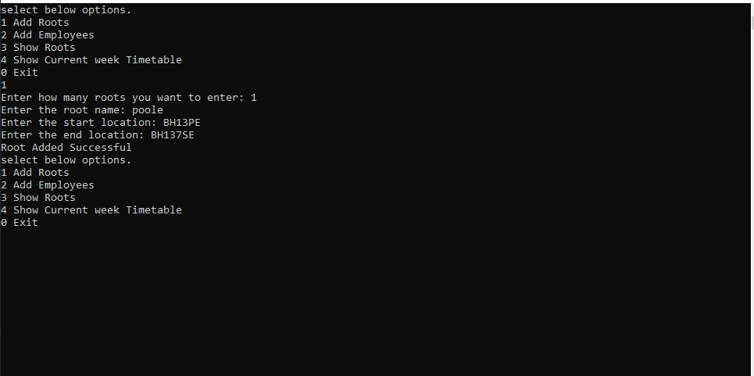

1. Add Employees

If you selected 2 then application will ask you how many employee you want to add (same as above option) and according to your response it will proceed.

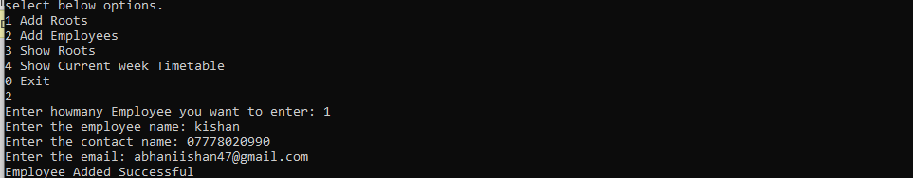

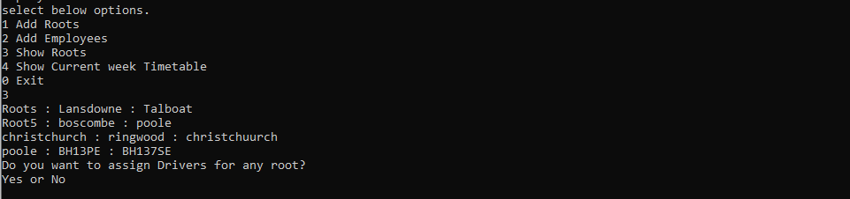

1. Show roots

If you have selected option 3 then it will display all the available routes.

Addition to that, application will ask you whether you want to assign driver for that route.

**If you want to assign driver type “YES” otherwise “NO”.**

**Yes**

You have three option now.

1 - Type Auto

2 - Type driver name

3 - Type Exit

**No**

**You will exit from the loop and if you want to exit from the application you need to choose 0 option.**

**Now back to the Yes option.**

1 – Type Auto

This option allow application to select driver randomly and assign driver availability.

This will assign 12 (Available for any shift) in availability.

And it will give you schedule later.

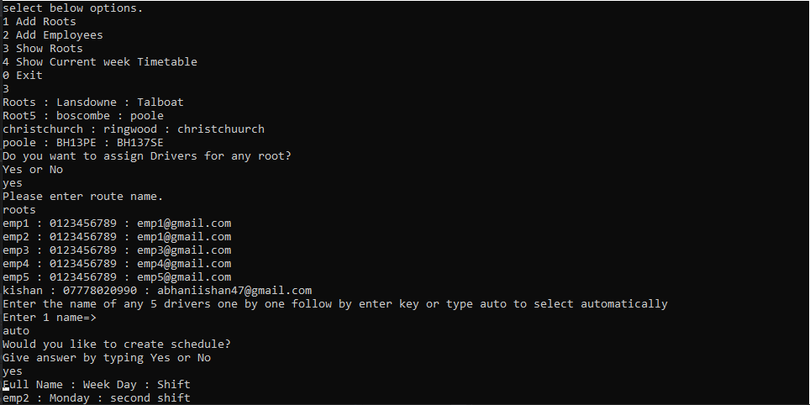

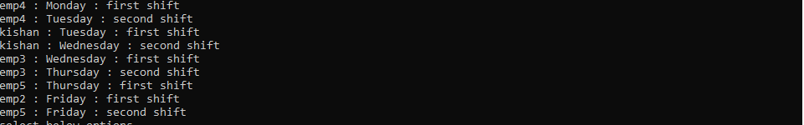

2 – Type driver name

Application will ask you five driver name (As we have set five driver per route: **Constants.driversperroute**).

After applying driver name, application will ask for driver availabilities for each day of the week.

If driver is available for first or morning shift only then type 1.

If driver is available for second or evening shift only then type 2.

If driver is available for any shift, then type 12.

If driver is on leave type 0.

After inserting all availability, system will ask you for the schedule if you want to or not.

Give answer by typing “YES” or “NO”.

And it will display schedule for that day.

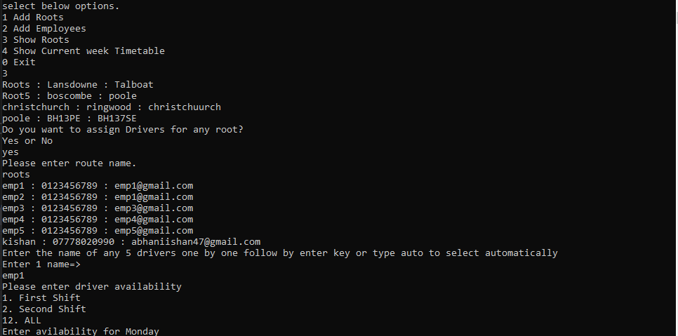

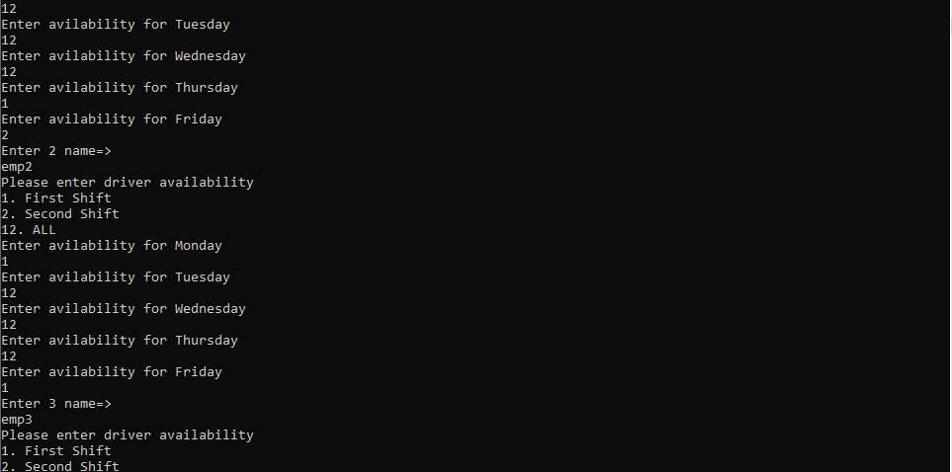

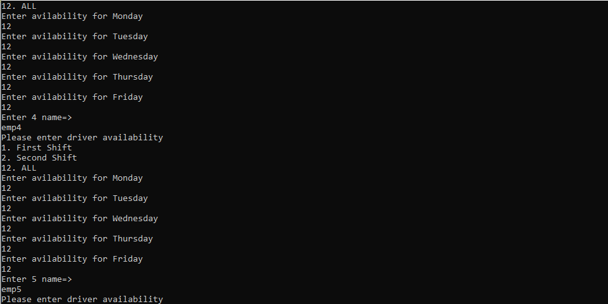

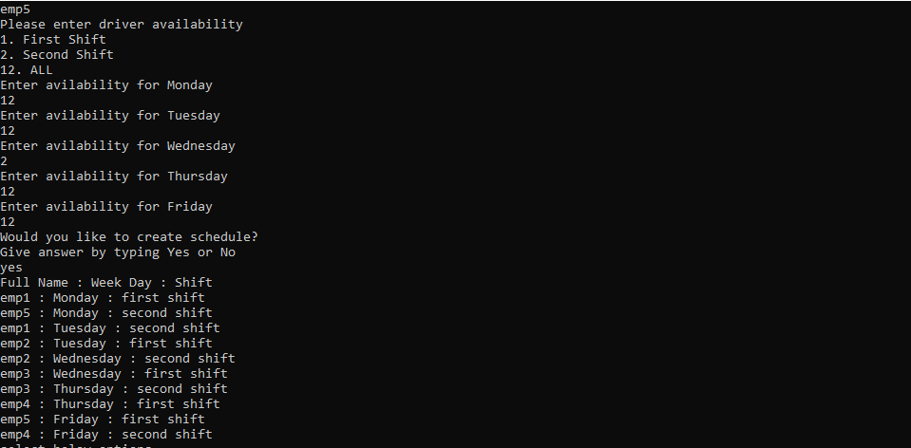

4 – Show current week Timetable.

It will show you current week time table.

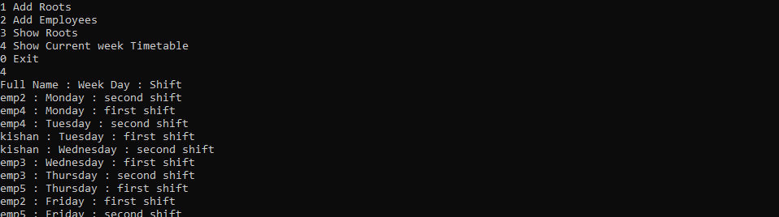

0 – Exit

To stop application.

Validation:

Drivers only ever drive the same route.

There are five drivers assigned to a route.

A driver cannot work more than one shift in a day

A driver can only work a maximum of two shifts per week

Note: This application doesn’t consist field validation like email, name and contacts field.

Limitation:

Not implement dependency injection.

Not used store procedure.

Not generic architecture.

This application for only week.

Application is not creating schedule with real date means months wise.

All variable names are in small it should be in camel case.